PROJECT REPORT

PREPARATION AND MAINTENANCE OF ZOHO BOOKS FOR DREAM HOMES REALTY

1. INTRODUCTION:

* 1. Overview:

Dream Homes Realty, a construction company, uses Zoho Books to track project expenses, manage subcontractor payments, and handle invoicing.

* 1. Purpose:

A residential construction company builds or renovates homes for individual clients or families. They may provide services such as: Design, Planning, Project management, Construction.

2. PROBLEM DEFINITION AND DESIGN THINKING:

2.1. Empathy map:

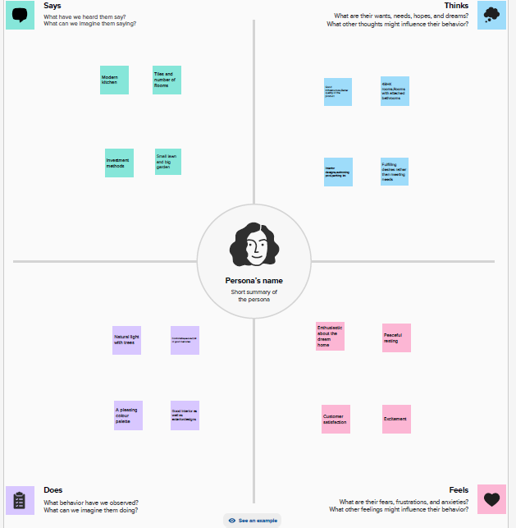

2.2. Brainstorming:

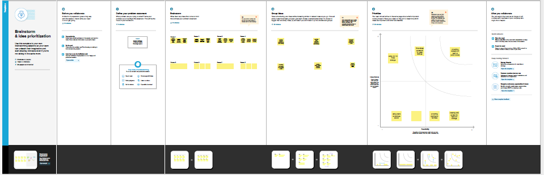3. RESULT:

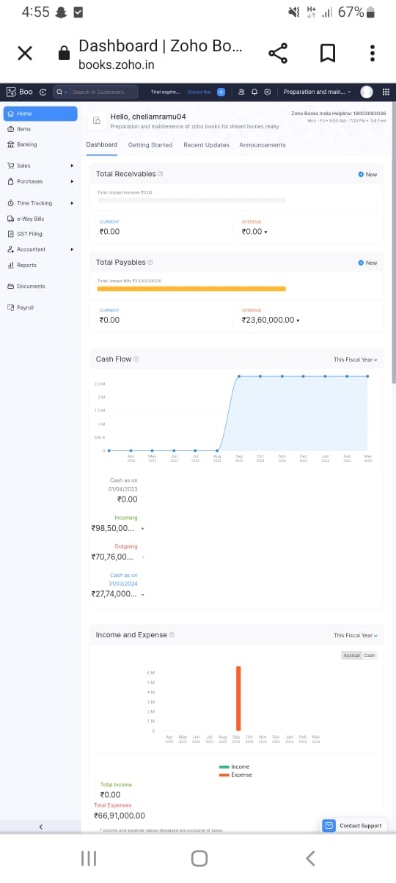



. 4. ADVANTAGES AND DISADVANTAGES:

4.1. Advantages:

* **Experience and expertise**

Construction companies have the experience and expertise to get the job done correctly.

* **Tools and equipment**

Construction companies have the necessary tools and equipment to complete most projects.

* **Financing**

Construction companies can often provide financing for your project.

* **Communication**

Communication is especially vital in construction, both on-site and in the office.

* **Collaboration**

Strong networks are formed on construction projects because everyone on the team depends on everyone else to get the job done.

4.2. Disadvantages:

Cost overruns, Delays, Labor shortages, Poor planning, Cash flow problems, High employee turnover, Stressful work, Safety risks, Litigation, Capital intensive, Funding difficulties.

Construction workers can face many risks, including: Equipment malfunction, Carelessness, Hazardous work conditions, Occupational diseases, Injuries.

5. CONCLUSION:

Construction companies are businesses that construct a variety of projects, including buildings, roads, and housing. They can provide cost-effective building solutions and attractive infrastructure that attracts investors.

**Construction companies must ensure quality control and assurance to deliver projects on time, within budget, and to the highest standards of excellence. They can do this by:**

* Adopting a comprehensive and integrated approach to quality control and assurance
* Developing formal directives and operating procedures
* Being proactive and seeking to be preventative or quickly reactive
* Having measurable indicators of success
* Equipping, supporting, maintaining, operating, improving, working, developing, administering, managing, controlling, and superintending all kinds of works.

THANK YOU